**A robust, generalizable model for canopy detection from generic LiDAR in the contiguous United States**

S. Jones1[1]*, R. El Kadiri1[2] and H.G. Momm1b

1Department of Geosciences, Middle Tennessee State University, Murfreesboro, Tennessee

*corresponding author: rj3h@mtmail.mtsu.edu

**Abstract:**

Many techniques have been developed to quantify different conceptualizations of self-interaction and patterns within spatial data. We propose a new metric and related algorithm that describes the geometric spatial disorder of geographic point sets, the “Index of Disorder” (IoD). The IoD algorithm was applied to synthetic and natural datasets and was shown to be able to differentiate between areas of high spatial disorder (randomly placed points) and low spatial disorder (e.g., curvilinear grids, wallpaper groups, and other repeating patterns). Because the IoD is a quantitative metric, it can be used on its own as an aid for identifying areas of unusually high or low spatial disorder or as enrichment for machine learning classification algorithms.

**Keywords:**

Point Patterns; Classification; Homogeneity, Algorithms; Forestry, Planning; Data Processing

**One Sentence Summary:**

The spatial disorder of any arbitrary point in a set of points can be quantified by comparing the relative positions of that point’s neighbors to the relative positions of its neighbors’ neighbors.

# Introduction

* Uses of LiDAR detection
* Existing canopy detection methods (both bespoke and general)
  + Closed source (ENVI, Arc, etc.)
  + Detection from point cloud vs. raster
  + Detection from aerial imagery (including photogrammetry)
* Need for generalized model

# Methods

## Model Design

LiDAR data in LAS format covering 10 watersheds across the contiguous United States were downloaded. The individual LAS files were then mosaiced together on a per-watershed basis using LAStools, and a suite of tools, including WhiteboxTools, laspy, GDAL, Orfeo, scipy and custom Python tools were used to process the LAS files into various raster products. These derived raster products were manually inspected along with aerial imagery to create training and validation data for each of the 10 watersheds (Table 3). 80% of the manually classified pixels were used as training data for a decision tree machine learning algorithm. A decision tree scheme was chosen over other machine learning algorithms because its output is easily interpretable, does not require normalized input and can be translated into a set of if-else statements, allowing the model to be distributed without a need for specific software to run the model.

The resultant decision tree was then validated against the remaining 20% of the data from the 7 trained watersheds, as well as 100% of the data from the 3 naïve watersheds. Input data was inversely weighted to amount of data for each watershed; that is, all watersheds were weighted equally regardless of differences in the number of contributing pixels. Raw accuracy scores as well as Cohen’s κ statistics were calculated individually for each watershed in this study.

## Derived Raster Products

A summary of the raster products generated from the collected LiDAR data is given in Table 4. The details of each product are given in subsequent sections. Because the classification model described in this paper is intended to be general, no data products generated made use of vendor-supplied classification codes. For rasters created by interpolating LiDAR point cloud values, a triangular irregular network (TIN) algorithm was used. All rasters created used a pixel size of 1m x 1m, regardless of source LiDAR point density.

### Digital surface model

A digital surface model (DSM) is created by interpolating the height values from only the first returns in a LiDAR point cloud. Thus, the DSM represents the elevation of the earth’s surface including above-ground structures such as buildings and tree canopies.

Though the DSM was used to generate other data products included in the model, the DSM itself was excluded as input to the classification model. This was done because non-normalized elevations have little to no predictive power for landcover type.

### Digital elevation model

A digital elevation model (DEM) is similar to a DSM but is created by interpolating the height values from only the last (rather than first) returns in a LiDAR point cloud. Thus, the DEM represents the elevation of the earth’s surface excluding some above-ground structures tree canopies. Some definitions of the DEM also require removal of built structures, but because this study did not utilize vendor-supplied classification codes, buildings could not be removed from the DEM directly, and so our generated DEM products do include built structures.

The DEM was excluded as direct input to the classification model for the same reasons that the DSM was excluded.

### Digital height model

A digital height model (DHM), sometimes referred to as a normalized digital surface model (nDSM) or height-above-ground model, is the result of the raster subtraction of the DEM from the DSM. The DHM represents the distance between the ground and any overhead structures, such as tree canopies or powerlines. Because building edges often produce multiple returns, building edges frequently appear in DHMs. The DHM is often used as a rough proxy for canopy height because its signature is dominated by tree, while building edges, powerlines, and other anthropogenic structures are minor contributors.

The DHM was excluded as direct input to the classification model but a modified version of it, described in the next section, was included.

### Filtered digital height model

Though the DHM roughly represents canopy height, the anthropogenic structures such as building edges and powerlines contribute significantly to the DHM in urban areas. Because of this, many investigators have proposed methods to distinguish the signature of trees from built structures through various means. Though many existing methods exist to filter built structures from a DHM, we elected to use a simple density filter due to its ease of implementation, quick runtime and high selectivity for canopy signals. The filter works such that, for every target pixel in the DHM, a 3 by 3 window is extracted. If over 30% of the pixels (3 or more) in the window are nonzero, then the target pixel’s value is retained. Otherwise, the target pixel is set to 0. This filter removes linear features, such as building edges and powerlines, while retaining more rounded features such as tree canopies. The result is a filtered DHM (fDHM).

Though the unfiltered DHM was excluded as a direct input to the model to limit false classification of building edges as trees, the filtered DHM was included as direct input.

### Intensity raster

A raster representing the average return intensity at each pixel was created by interpolating LiDAR return intensity values. Because intensity values are not normalized and are a function of sensor type, pulse strength, and aircraft altitude in addition to the land cover type being sensed, the intensity rasters were not used as classification model input. However, they are usefully qualitatively and were used to aid manual land cover classification.

### Return raster

A raster representing the average number of returns in a pixel was created by interpolating the return number of the last return for each LiDAR pulse. Like the intensity raster, the number of returns is a function of variables beyond just the land cover type and so was excluded from being used as classification model input, but it was used to aid manual land cover classification.

### Slope rasters

For each elevation-based model (DSM, DEM, DMM, fDHM) a slope raster was created representing the maximum slope between a given pixel and its 8 neighbors. The slope is given in degrees. These products were included as direct input to the classification model.

### Roughness rasters

A “roughness” raster was created for each elevation-based model (DSM, DEM, DMM, fDHM) by applying a filter that returns the maximum difference in values between a target pixel and its 8 neighbors. These products were included as direct input to the classification model.

### Laplacian filtered rasters

Laplacian filters are commonly used to emphasize areas of rapid change in imagery. This emphasis on rapid change has led to widespread use of the Laplace filter for edge detection, but a Laplace-filtered image can be thought of more generally as a textural derivative of the parent image. Laplacian filters can be expressed as a convolution operation, and the convolution matrix used in this study is $\left[\begin{matrix}-1 & -1 & -1 \\ -1 & 8 & -1 \\ -1 & -1 & -1\end{matrix}\right]$. A Laplacian-filtered raster was created for each elevation-based model (DSM, DEM, DMM, fDHM), and these products were included as direct input to the classification model.

### Haralick textures

Haralick textures, or Haralick features, is the name given to a set of indicators derived from a matrix describing frequency of occurrence of specific value-pairs within subsets of an image. This frequency matrix is called the gray level co-occurrence matrix (GLCM). These derived features are referred to as textures because they tend to quantify the relationships between a given pixel and its neighbors.

From the DHM, we generated 8 Haralick textures: energy, entropy, correlation, inverse difference moment, inertia, cluster shade, cluster prominence and Haralick correlation. However, Haralick textures were ultimately excluded as input to the classification model due to the computational resources required and low boost in model performance compared to models that excluded the textures.

## Study Areas

The 10 areas of interest selected for this study were chosen for their diverse geomorphological, anthropogenic and ecological signatures as well as availability of LiDAR data. Seven of these study areas were selected to train the model (“trained” watersheds), which was validated against the three remaining watersheds (“naïve” watersheds). Characteristics each watershed can be found in Table 1, and an overview of each study area is given in subsequent sections. Characteristics of LiDAR data used to generate data products for each watershed can be found in Table 2.

### 010500021301 – Penobscot, ME

Branch Lake watershed (USGS hydrologic unit code: 010500021301) is located approximately 10 miles to the northeast of the town of Penobscot, Maine, and drains to the eponymous Branch Lake. The watershed has a total area of 80.0 square kilometers. The majority of the watershed consists of coniferous forest and open water. Limited agricultural land, open fields and exposed rock are present as well. Overall development in the watershed is low. Approximately 10.4 square kilometers, or 13.0%, of the watershed was manually classified. The LiDAR data utilized in this study for the watershed was collected between 4/19/2015 and 5/12/2015 with a nominal pulse spacing of 0.70m.

### 030902040303 – Naples, FL

### 0070801050901 – Kelley, IA

### 080102040304 – Western TN

### 130202090102 – Alamo, NM

### 140801040103 – Central CO

### 180500020905 – San Francisco, CA

### 080902030201 – New Orleans, LA

### 100301011309 – Helena, MT

### 102901110304 – Freeburg, MO

# Results and Discussion

## Theoretical Evaluation

For point patterns generated based on regular grids, the IoD differentiates greatly between the unperturbed points (within red circle) and perturbed points (outside red circle in Figure 5A-D). In more complex patterns, the IoD yields mild to moderate differentiation between the unperturbed and noisy patterns than the patterns based on regular grids. Nonetheless, in all cases the lowest IoD values are observed in the center of the figures, and a rapid increase in the IoD is observed as the pattern deviation approaches and exceeds the Km of the scoring function, indicating that the IoD is capable of measuring relative levels of disorder and/or order within a dataset. Importantly, the IoD is agnostic to the general form of patterns, and thus is capable of detecting patterns with no knowledge of the exact form of the patterns.

Because pattern detection is scale-dependent, alternative input parameterization will result in varying levels of discrimination between ordered and disordered points. Optimal parameterization is generally simpler to achieve when patterns are also simple.

Realignment of neighborhoods during calculation of the IoD generally reduces both the unperturbed and noisy perturbed points by a similar amount. However, in certain cases, realignment can cause a slight increase in differentiation (*Figures 7 and 8*). In other words, realignment depresses the IoD of ordered points more than it depresses the IoD of disordered points. Discrete repeating patterns in these examples, sometimes referred to as “wallpaper groups” benefit from realignment because the effect of pattern offset (*Figure 8*) becomes significant. Not realigning points will elevate the IoD even though pattern correspondence exists. Allowing neighborhood realignment can significantly increase computation time because point registration may be repeated multiple times per neighborhood rather than just once, so realignment should only be used when pattern offset is anticipated to occur and needs to be corrected for. In some cases, pattern offset may actually be of importance for feature identification, and so realignment is undesirable.

## Natural Evaluations

### Site 1

Sensitivity analysis was performed by varying IoD input parameters of neighborhood radius *r* and sigmoidal assigned threshold value Km and comparing results with reference datasets (Table 3). The maximum kappa coefficient of agreement value of 0.81, interpreted as “substantial agreement”, is achieved when the scoring function has a Km of 5 and the neighborhood radius is 80 meters. The corresponding overall accuracy for this classification is 96%.

The mild planting pattern heterogeneity of the orchard increased the calculated IoD somewhat, but overall the orchard trees are largely differentiable from the surrounding forest due to the gridded nature of the orchard (Figure 9). The apparent heterogenic pattern of the orchard is likely as much due to inaccuracies in crown extraction from the DHM than it is due actual heterogeneity; crown extraction from LiDAR is itself highly parameter dependent. The high kappa value of this classification suggests that the IoD alone is sufficient to differentiate the orchard from surrounding trees without any other supporting data.

The classification quality of the IoD is highly sensitive to its parameterization (Table 3). Because patterns are a fundamentally scale-dependent phenomenon, it is not surprising that algorithms that quantify them must be parameterized appropriately. The neighborhood radius used to parameterize the IoD describes the scale of the anticipated patterns, while the Km describes the level of expected deviation within the patterns. Though *r* is a parameter that will be present in any implementation of the IoD, Km is technically a parameter of the sigmoidal function used for scoring and point assignment. If the classification quality is maximized and a strongly homogenous pattern is being differentiated from a highly disordered nonpattern, then *r* and Km respectively characterize the actual pattern scale and deviation. Thus, the characteristic scale of the orchard in Site 1 is between 70 to 80 meters, and the threshold of the pattern deviation before points become disordered is approximately 5 meters.

Because of this scale dependence, the IoD is not appropriate when there is no prior knowledge of scale of pattern deviance or when trying to quantify patterns with multiple scales. In those cases, it is recommended using the IoD the characterize pattern scales on a subset of data before applying it more broadly.

### Site 2

Similarly, sensitivity analysis of was performed for IoD calculations in Site 2 (Table 4). The maximum kappa value of 0.74, interpreted as “substantial agreement” is achieved when the scoring function has a Km of 2 and *r* is 25 meters. The corresponding overall accuracy for this classification is 87%.

Like Site 1, the planted trees in this study area display a gridded structure that explains the lower IoD in the planted zones relative to the surrounding mature forest (Figure 10). The kappa coefficient of agreement suggests planted trees are differentiable from the surrounding trees based on the IoD alone. The sensitivity evaluation suggested a characteristic scale and pattern deviance for the planted trees, which are 25 meters and 2 meters respectively (Table 4).

### Site 3

Performing sensitivity analysis, the maximum kappa value of 0.44, interpreted as “moderate agreement” and overall accuracy of 76% are achieved when the scoring function has a Km of 6.5 and *r* is 19 meters (Table 5).

The classification agreement is lower at this site than previous sites. This is unsurprising due to the increased pattern complexity displayed by the building centroids (Figure 11). While the planted trees at the previous sites displayed relatively simple grids patterns that contrasted with the highly disordered positioning of the naturally occurring trees, the buildings in this site are arranged in gridded blocks that vary in scale, orientation, and deviance. Though the main buildings generally adhere to straight lines within these blocks, the exact position of their centroids can vary along this line and occasionally there is no discernible pattern to their placement at all. Conversely, auxiliary buildings overall do not display the level of pattern adherence that the main buildings do—not every main building has an auxiliary building, and when an auxiliary building is present its placement on the property is relatively varied—but their placement is not perfectly random. Occasionally a block will have enough auxiliary buildings that a pattern similar to that of the main buildings emerges.

These phenomena together elevate the IoD of the main buildings and reduce the IoD of the auxiliary buildings, reducing the ability of the IoD alone to differentiate these building types. However, the IoD has some level of classification power even in complex systems and so can be used to improve the accuracy of classification schemes based on machine learning; the IoD can be calculated and added to a dataset, increasing its dimensionality.

Higher classification results were achieved with a *r* of 19 meters and a Km of 6.5 meters. The respective interpretation of these values as the characteristic pattern scale and pattern deviation is not necessarily as clear is it is for Sites 1 and 2, which consist of strongly patterned and nonpatterned points. The placement of building centroids in Site 3, in contrast, are moderately patterned (main buildings) or weakly patterned (auxiliary buildings). Because of this, the ideal *r* and Km do not necessarily describe either pattern but rather represent, respectively, a discriminatory scale and a discriminatory deviance.

## Impact of Alternative Implementations of the IoD

### Scoring and Point Assignment Functions

Swapping any monotonic increasing function with another for the purposes of scoring will not change the relative ranking of the disorder of the points, and thus the choice of scoring function is ultimately an aesthetic choice. However, it is convenient to use the same function used to calculate assignment costs to calculate the IoD to simplify interpretation of the results. The assignment cost function *does* have an impact on what points are assigned to one another, and thus may have an impact on the relative ranking of IoD scores for points in a set (*Figure 4*). Using the Euclidean distance between points as the assignment function results in many suboptimal pairings; many points are assigned to a point for which there is no obvious correspondence but results in an overall minimization of the assignment cost. Using a sigmoidal function, however, allows for more intuitive assignments for most points by reducing penalties for assignments with large Euclidean displacements, in turn allowing assignment of points very close in space to one another.

Other functions, such as the square root of the Euclidean distance, similarly reduce the penalty for large assignment displacements and generally improve assignment. An advantage of the sigmoidal function over other options is that the midpoint (Km) imparts additional scale-awareness to the IoD; the Km describes the expected deviation, or “noise” within a pattern, and so displacements below Km are considered within the tolerance of the expected noise level and punished less. Without Km or a similar metric, the IoD is aware of characteristic pattern scales (via the neighborhood radius) but will be unable to account for intra-pattern noise.

### Realignment Function

There are many alternative methods for realignment, typically called point set registration or point matching algorithms in the field of computer vision. Discussion of their differences and similarities is beyond the scope of this paper, but it is worth noting that all registration methods must either calculate or be provided with the correspondence between the point sets being aligned.

Additionally, realignment algorithms are not guaranteed to “correctly” align the neighborhoods, and realigning neighborhoods may also lead to spurious reductions in the IoD even when no pattern similarity exists. If this decrease exceeds reduction in IoD when true pattern correspondence exists, then realignment will actually reduce the ability of the IoD to differentiate ordered and disordered point sets (*Figure 7*). Thus, the use of realignment may or may not be appropriate depending on the intent of the study. Realignment is also computationally expensive as it requires repeated recalculation of neighborhood point assignments.

# Conclusions

Existing methods to quantify disorder have relied on either raster data or non-geospatial algorithms that quantify the disorder of point data based on the assumption that order is grid-like, an assumption that is often violated in geospatial contexts. Thus, the Index of Disorder algorithm provides a new way to quantify spatial disorder of individual points in a set, which is achieved by quantifying the similarity of a point’s “neighborhood” to the neighborhoods of its neighbors.

Datasets evaluated in this study indicate that the IoD alone is sufficient to differentiate planted stands of trees, which tend to be planted in curvilinear grids, from mature forest, which displays no pattern in the positioning of trees. On this principle the IoD can be used to estimate reforestation extent or identify orchards. The IoD can also be used to enrich datasets for classification in systems where spatial patterns alone may not be sufficient to make a classification, such as when classifying building types in complex urban systems.

Because spatial patterns are inherently scale-dependent phenomena, the IoD requires parameterization in order to satisfactorily quantify disorder. Thus, its utility may be limited in systems where the scale of the patterns being analyzed is poorly understood or if the pattern scale is variable across the study area. However, this limitation allows the IoD to be used backwards: if there is a priori knowledge of the classification labels of points in a system, then then an optimization algorithm can be applied to the IoD in order to estimate the scale of the pattern and magnitude of the pattern deviation.

Because the measure is quantitative (though relative) it can also be used as an additional dimension of analysis for problems that benefit from data enrichment, such as machine learning classification. Further work is planned to explore in more detail the effects of alternative implementations of the IoD, as well as its utility in classification problems beyond the scope of what is presented here. In particular, the IoD may be of use in quantifying patterns present in 3-dimensional point sets.

# Data and Materials Availability

All code used in the analysis for this paper is publicly available at <https://github.com/rsjones94/point-disorder>. The digital height models used to generate the tree crown datasets and Nashville building centroids are available on request.

# Tables and Figures

Table 1. Information related to each study area used to train or validate the model.

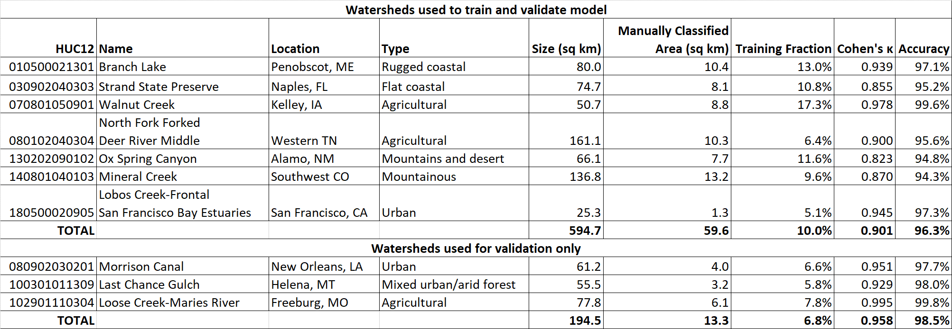

Table 2. Information related to LiDAR characteristics for each study area.



Table 3. Training and validation data classification scheme used in this study.

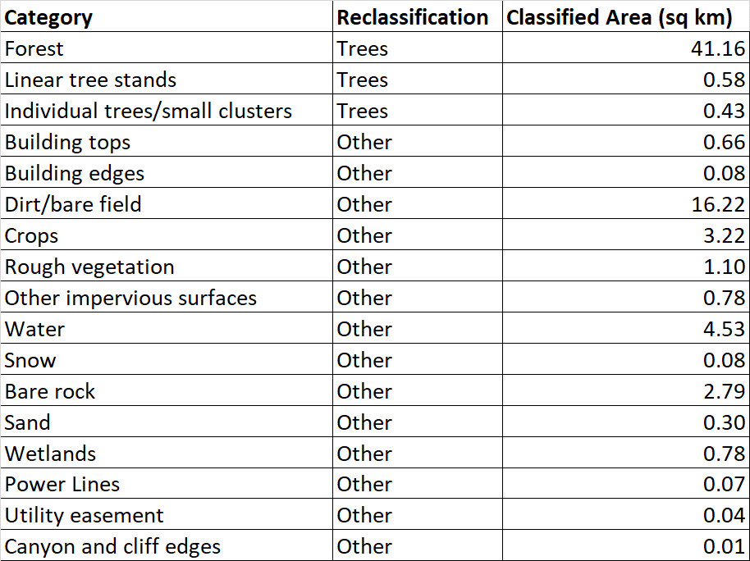

Table 4. Summary of derived raster products used in the model.

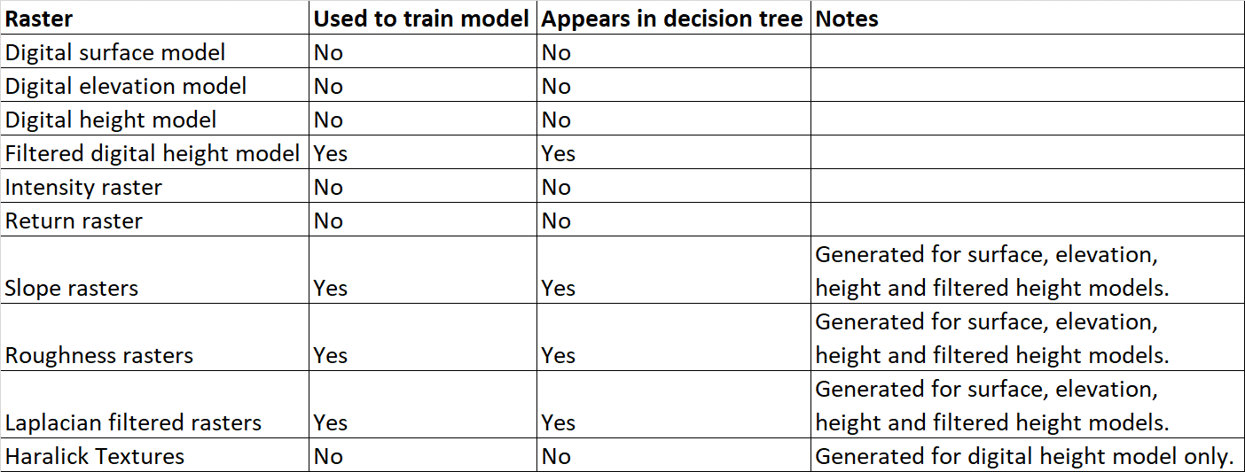

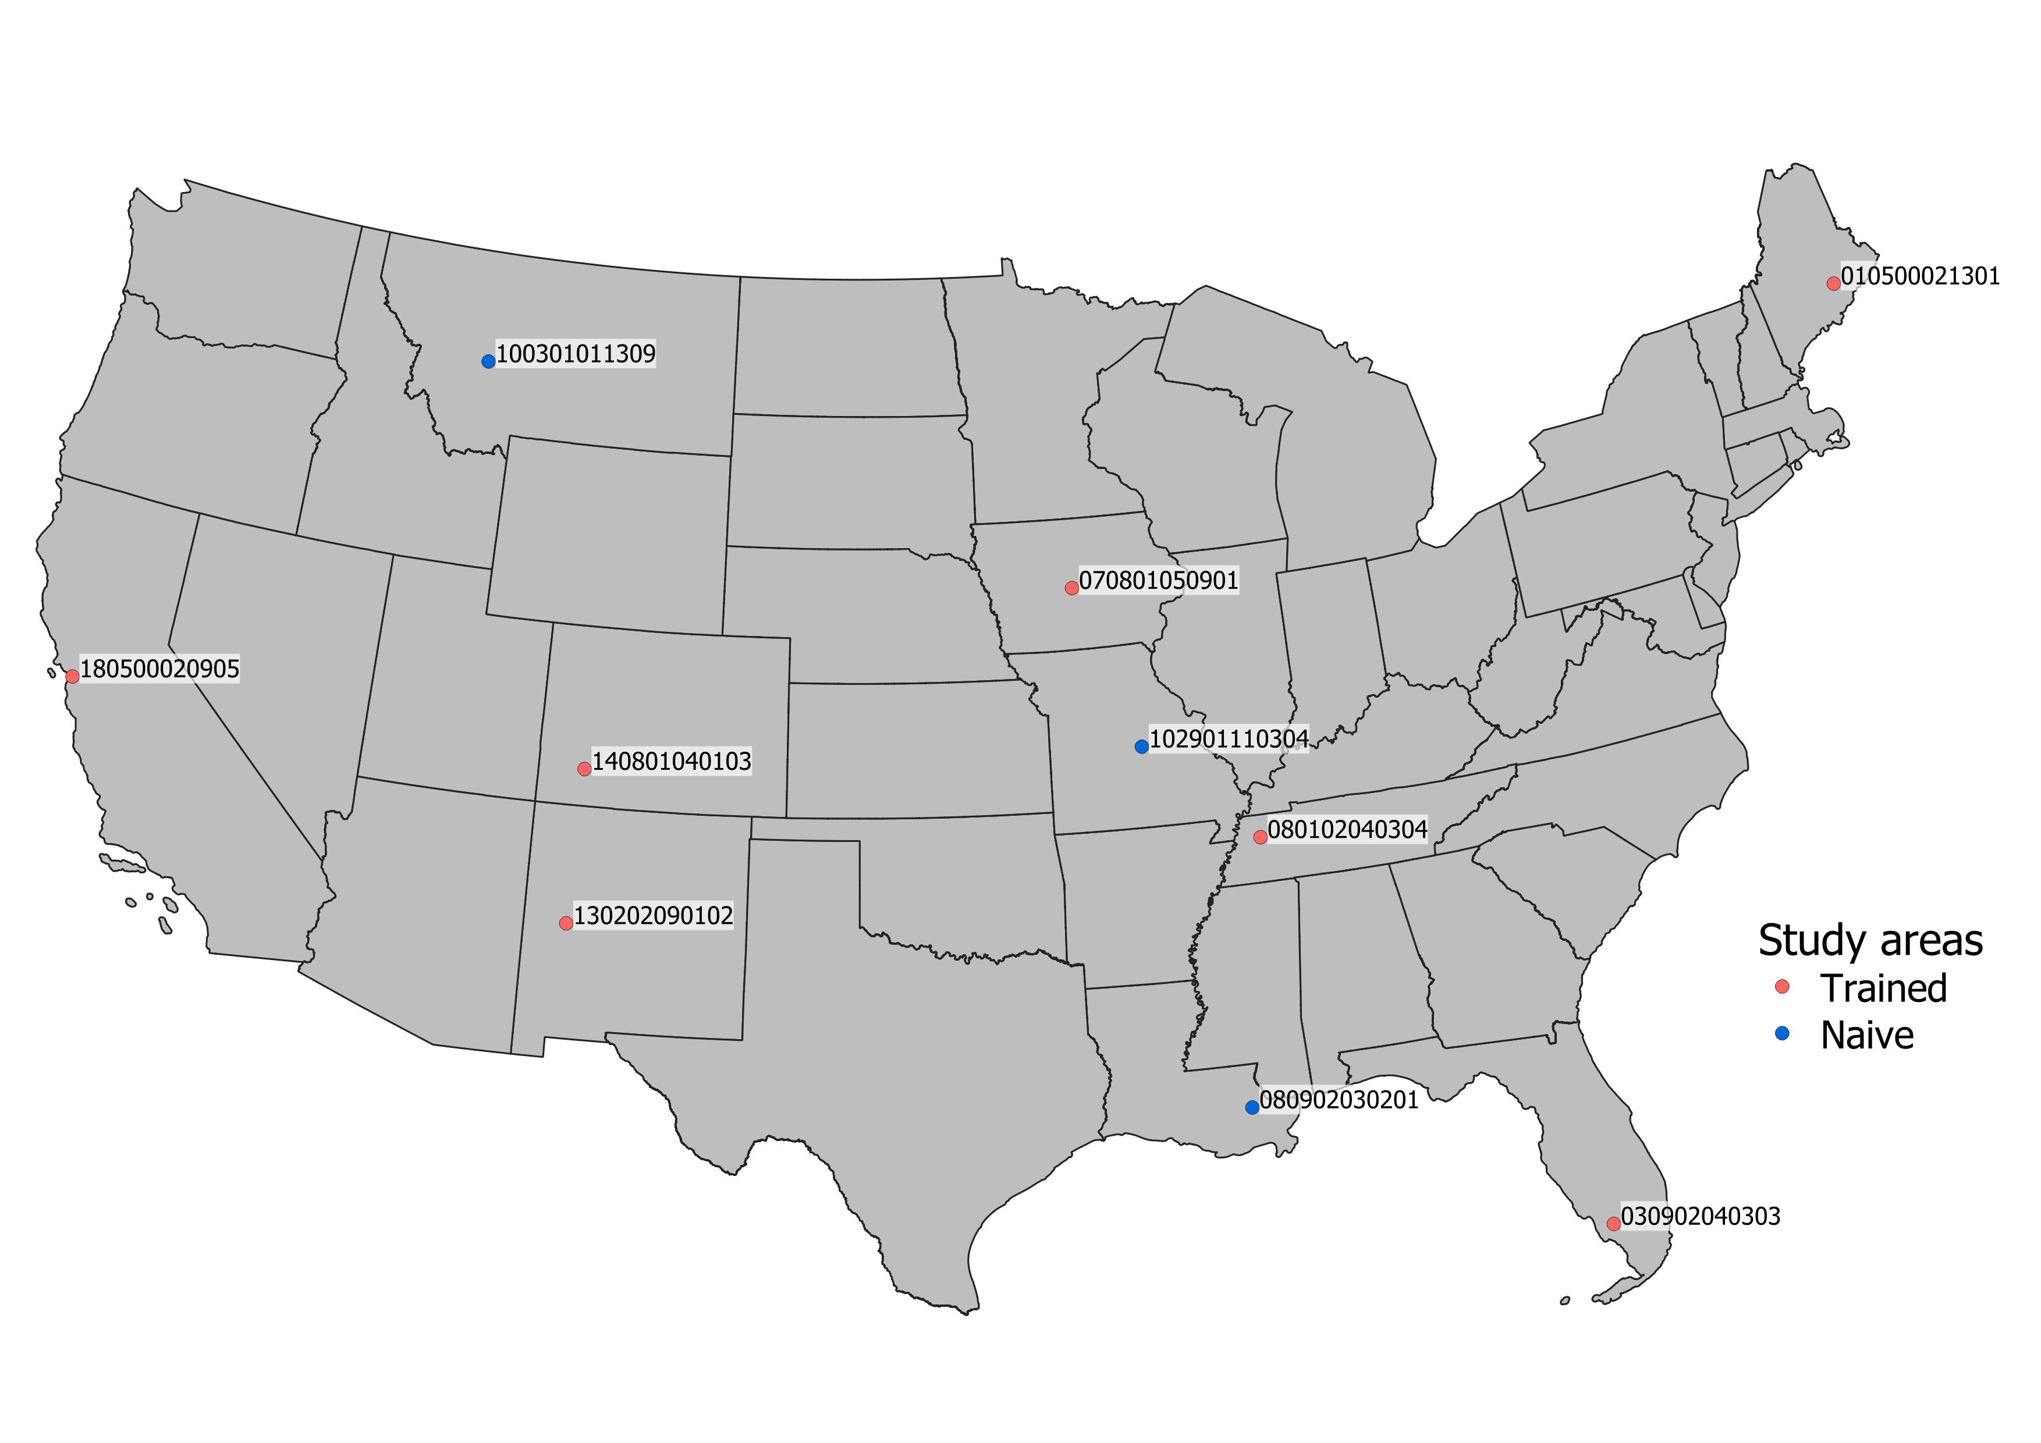

Figure 1. Distribution of watersheds analyzed in this study.

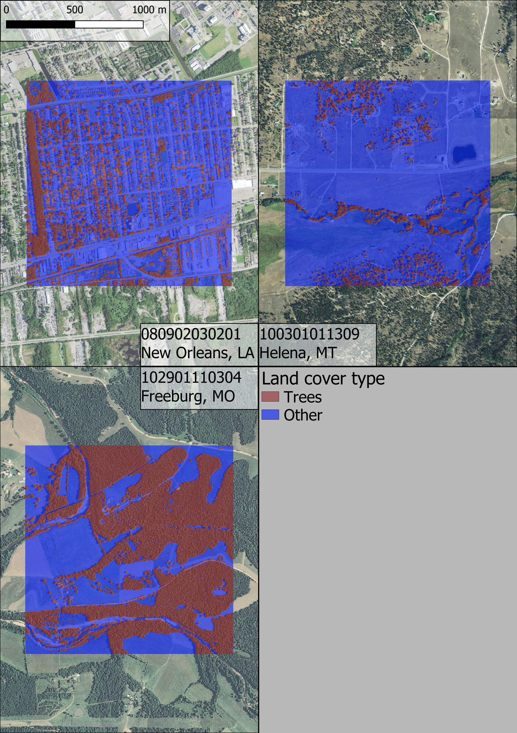

Figure 2. Sample classifications for three of the naïve study areas. Note that the orthoimagery for the New Orleans watershed is not perfectly contemporaneous with the LiDAR input; some trees in the study area were removed between LiDAR and orthoimagery data collection.



Figure 3. Decision tree of the final model. fidhr = filtered digital height model roughness. dsmro = digital surface model roughness. dsmlp = laplace filter of digital surface model. demsl = slope of digital elevation model. dsmsl = slope of digital surface model.

# Acknowledgements

We would like to thank the Natural Resources Conservation Service for providing funding for this project.

# Funding

This work was supported by the Natural Resources Conservation Service (agreement number NR194741XXXXC005).

# References

Potential works:

* Weinstein, B.G.; Marconi, S.; Bohlman, S.; Zare, A.; White, E. Individual Tree-Crown Detection in RGB Imagery Using Semi-Supervised Deep Learning Neural Networks. Remote Sens. 2019, 11, 1309 **AND** Geographic Generalization in Airborne RGB Deep Learning Tree Detection Ben Weinstein, Sergio Marconi, Stephanie Bohlman, Alina Zare, Ethan P White bioRxiv 790071; doi: <https://doi.org/10.1101/790071>
  + Related to <https://github.com/weecology/DeepForest>. Covers a generalizable RGB-based model for crown-detection. Essentially our work, except imagery based and goes a step further (detecting crowns). Maybe we can implement crown detection?
* <https://pypi.org/project/forestutils/>
  + Tree extraction directly from point clouds. I believe it needs full color point clouds, which come from either photogrammetry or full-color (i.e., expensive) LiDAR scans
* A Segmentation Method for Tree Crown Detection and Modelling from LiDAR Measurements - <https://link.springer.com/chapter/10.1007/978-3-642-31149-9_7>
  + 2012 paper on the inverted watershed (raster-based) method of crown detection
* Trends in Automatic Individual Tree Crown Detection and Delineation—Evolution of LiDAR Data
* <https://www.researchgate.net/publication/259128823_High-resolution_tree_canopy_mapping_for_New_York_City_using_LIDAR_and_object-based_image_analysis>]
* Characterizing urban surface cover and structure with airborne lidar technology
  + Contains schematic for image filter that remove linear structures (building edge detection)
* The Comparison of Different Methods of Texture Analysis for Their Efficacy for Land Use Classification in Satellite Imagery

1. Responsible for design, implementation and testing of model, collection and processing of data, and drafting of manuscript.
2. Responsible for supervision of model design, manuscript drafting and revision.